HEALTH PROGRAMMES IN INDIA

  - Introduction
Tackling disease and pathogens remains the highest priority of the Health authorities in the country. The Government has undertaken specific measures in this regard, the designing and implementation of specific Health Programmes being a major contributing factor. In the theory blocks of the course you have learnt about the various programmes presently operational in the country. Without going into details here we shall just enumerate the major programmes, enlist some major challenges faced in the implementation, learn about the techniques of evaluation of any Health Programme and analyze the situation using practical examples.

  - Key Concepts
    - Major Health Programmes in India
- National Rural Health Mission (NRHM): incorporating AYUSH, IPHS and PRI
- National Urban Health Mission (NUHM)
- Reproductive and Child Health Programme (RCH)
- National Vector Borne Disease Control Programme (NVBDCP)
- National AIDS Control Programme (NACP)
- Revised National Tuberculosis Control Programme (RNTCP)
- National Leprosy Eradication Programme (NLEP)
- Integrated Disease Surveillance Project (IDSP)
- Integrated Child Development Services (ICDS)
- National Water Supply and Sanitation Programme
- National Cancer Control Programme
- National Programme for Control of Diabetes, Stroke and Cardiovascular Diseases
- National Mental Health Programme
- National Programme for Control of Blindness (NPCB)
- National Iodine Deficiency Disease Disorder Control Programme

Components of the Programme to be Evaluated
Relevance: is the programme really needed and is it targeting the individuals in need, referred to as “Relevance Evaluation” or “Need Assessment”.
Progress: to determine if the implementation matches the plan, to recognize the achievements and shortcomings referred to as “Implementation Evaluation”.
Process: to identify the strengths and weakness, help to understand the Operationalization of the programme.
Effectiveness: to identify if the results meet the predetermined objectives, examines the relationship between programme activities and the observed consequences.
Efficiency: analyzes the results in terms of resources put in to maintain the programme “the input-output analysis”.
Impact: to study the long term effects of the programme, the overall effect on health status and community.
Tools for Evaluation
- Records from Governmental / Non-Governmental sources
- Case studies
- Qualitative studies
- Sample surveys, cross sectional studies
- Cohort studies
- Panel studies
- Controlled Experiments and Intervention studies

  - Activities
Activity 1
Major Health Programmes at sub-centres are listed on the worksheet. You are to:
Name the target group(s) for each programme
Name the community organization(s) likely to support the programme
Health Programmes at the Sub Centers | Target Groups | Community Organizations likely to Support the Programme
Malaria Programme

Tuberculosis Programme

HIV / AIDS Programme

Leprosy Programme

Integrated Disease Surveillance Project (IDSP)

Immunization Programme

Pulse Polio Immunization Programme

RCH Programme

School Health Programme

Mental Health Programme

Other Programmes

Activity 2
Chalk out an evaluation plan for undertaking an evaluation of the AIDS Control Programme in the state of Delhi. Enumerate the following while designing the Evaluation service:
- Rationale
- Provide a detailed overview of the number and type of service centers to be selected
- The methodology including the study design
- Indicators to be used to carry out the evaluation process

Activity 3
Enumerate the steps to carry out a Formative (concurrent) evaluation of the National Leprosy Eradication Programme utilizing the different indicators mentioned under the Simplified Information System?

Activity 4
Design a protocol under the following headings to conduct a mid-term evaluation of ASHA workers and Janani Suraksha Yojna (JSY) in your field area using the performance evaluation indicators?
- Rationale
- Introduction
- Aims and Objectives
- Literature review
- Material and Methods
- Time line
- Budget

Activity 5
- Conduct a situation analysis and functionality study of Sub Health Centers (SHCs) in your field practice area.
………………………………………………………………………………………………………………………………………………………………………………………………
- Compare the situation analysis with the available Indian Public Health Standard (IPHS) guidelines.
………………………………………………………………………………………………………………………………………………………………………………………………
- Critically review the functioning and availability of different equipments on the basis of the Study. Give specific recommendations for the better functioning of any of the SHCs in your area.
………………………………………………………………………………………………………………………………………………………………………………………………

Activity 6
- Enlist the steps required to carry out an epidemic investigation.
………………………………………………………………………………………………………………………………………………………………………………………………
- Enumerate the information necessary to do a Line Listing of Cholera cases in your field practice area.
…………………………………………………………………..………………………………………………………………………………………………………………………..
- Develop a schedule for rapid assessment of deaths resulting from cholera in your field practice area
………………………………………………………………………………………………………………………………………………………………………………………………
- Prepare a spot map for the cases in the area.

MODEL VILLAGE
Concept of Gram Swaraj
The concept of self-governing villages in the Indian context is available in Vedas and is as old as 1200 B.C.
During pre colonial period Panchayat (an assembly of 5 persons) at every village level was administering the villages.
In 1835-36 the then governor general of Indian sir. Charles Metcalfe declared the Panchayat as little republic.
At the time of writing the constitution of India there was no provision of Panchayat in the first draft.
After major debates finally a provision was included in Part-IV of constitution, which however was not mandatory.
73rd constitutional amendment in 1992 had widened the Panchayat Raj base and made Panchayat as local self-government.
Now there is elected Panchayat at every village level to function as a government for that village with the people support in the form of gram Saba.
There are financial & power devolution in the form of financial commission grants and other governmental schemes.
Responsibilities
Panchayats have to prepare 5 yrs plan & approve the village plan and budget for the year.
Approve the audit report on the village Panchayat accounts of the previous year.
Review the progress of the implementation of all schemes.
Construction, repair and maintenance of all villages roads and of all bridges, culverts, road-dams and cause ways on such roads.
The extension of village-sites and the regulation of building
Lighting of public roads and public places in built up areas.
Construction of drains and disposal of drainage water & sullage other than sullage.
Cleaning of streets, removal of rubbish, heaps & other improvements of the sanitary condition of the village.
Provision of public latrines and arrangements to cleanse latrines whether public or private.
Opening and maintenance of burial and burning grounds.
Sinking and repairing of wells and construction and maintenance of water works for the supply of water for drinking, washing and bathing purposes.
Controls of fairs and festivals
Why Model Village ?
Despite the existence of Panchayat Raj constitution for almost a decade in all over the country except few states like Pondicherry & Jharkand.
There is no significant growth among the panchayats to function as a local self-government.
There are supporting institutions, NGOs and Govt. departments to work for making the panchayats to delivers the constitutional mandates.
In this situation, if there is demonstrating models for total development by the panchayats. It will create ripple among the other panchayats by showcasing the roll models.
This is easy to replicate more and more models using grassroots democracy.
How a Model should be ?
Providing housing for all communities.
Effectively maintaining the water bodies and providing safe drinking water.
Provision of sanitary facilities, effective disposal of solid waste and recycling of used water.
Establishing infrastructural facilities.
Protect the environment by planting trees, kitchen gardens and smokeless chulas.
Providing education for all– computer education & governance.
Providing housing for all.
Ensuring the health facilities and campaigning.
Ensuring social security by supporting orphans, widows, mentally retarded peoples and Senior citizens.
Eradicating untouchability & establishing community harmony.
Using effective and eco friendly building material.
Youth development.
Example
Kuthambakkam village is located in Poonamallee union, Thiruvallur district of Tamilnadu. This village is an agriculture-based village. It is situated 31 KMs West of Chennai and 18 KMs East of Thiruvallur. The name ‘Kuthambakkam’ had evolved from Koothanbakkam, which refers the famous Shiva Temple here.
This village covers area of 36 square kilometers. 700 acres of wetland and 1100 acres of dry land are available in the village. Nemam Kuthambakkam Lake, which is located in the West, is the source water for agriculture. This comfort of water source makes good agriculture possible.
Around 9000 meters length of internal roads is there across the panchayat covering all the seven hamlets. Union roads covering 1.6 KMs are there from Vellavedu to Kuthambakkam. Irulapalayam – Padur highway and Nemam – Chetipedu Highway are connecting the village to the main road. The population of the village is 5190 out of which 52% are dalits.
Before the New Panchayat Raj 1996

Though this village is near to Chennai city, there were lot of social problems existed in this village. This was mainly because of many landless schedule casts families leading their life in absolute poverty. The problems prevailed were,
• Illicit arrack brewing activities and easy availability of illicit liquor
• Caste clashes between dalits and non dalits
• Inadequate basic facilities like, safe drinking water, drainage and internal roads
• No regular income due to unemployment
• No assurance to food
• Violence against women and children existed

After the New Panchayat Raj 1996

Notable changes happened due to the following steps taken by the panchayat.
• Panchayat prepared a five year plan for a holistic development
• Ensured people’s participation in Gram Sabha
• Pathways created for social transformation through social integration programs
• Livelihood creations by value addition of village produces within the village
• Housing for all
• Organising the poor people in to self help groups
• Activities were planned using good database with the help of information technology
• Village information centre was formed
• Rehabilitation programmes for those who are rescued from the illicit arrack brewing activity.
• Water bodies were deepened to increase storage capacity
• New check dams constructed
These programmes were implemented phase by phase, which paved way for social and economical development in the village.

DEVELOPMENT ACTIVITIES
Road Facilities
• All inner roads up to 8000 meters length in all the residential areas of the Kuthambakkam panchayat had been converted into concrete roads by ‘Nammaku Naame’ scheme and Equalization incentive grant support.
• The rest of the roads were converted into asphalt roads using various schemes like MLA constituency development fund, MPLADS funds, District panchayat funds and panchayat union general fund.
Sanitation
- Open sewage in Kuthambakkam south had been converted to granite walled drains and Ambedkar Human Resource Development centre was formed at the centre of the south colony.
- A big storm water drain was formed in Kuthambakkam south along the chetipedu main road.
- Drainages were constructed at all the required places in Kuthambakkam south.
- Drainages were constructed at all the required places in central Kuthambakkam
- Drainages were constructed at all the streets in Kuthambakkam north
- Flood water drainage was constructed across the main road in Irullapalayam and drainage channels were constructed at the inner area of Irullapalayam
- Women toilet complex was constructed and maintained well in Kuthambakkam north
Water Distribution
- Quality drinking water is ensured to all the families in the panchayat.
- Three new overhead tanks were constructed with the support of Tamilnadu Water supplies
Drainages Department in Utkottai, Samathuvapuram and Kannadapalayam. The distribution
of water is going on well in these areas.
Electricity Saving
- Streetlights with CFL lamps were installed to reduce maintenance cost and also to save electricity. By this way the panchayat saves electricity worth Rs.50.00 per post per month. Totally Rs 15,000 per month is saved. More over, a self help group was getting trained for the production of covers for the CFL lamps
- An innovative method of running 1 HP motors instead of 5 HP motors is practiced to pump water through which more than 50% electricity is saved
Construction of Samathuvapuram
When the samathuvapuram scheme was introduced in 1996, Kuthambakkam panchayat had requested one for it. As the result of committed effort for land allocation, finding beneficiaries, introducing new architectural models this samathuvapuram has become one of the best out of 110 samathuvapurams built across tamilnadu.
Abolition of illicit arrack
In 1996, when the new panchayat sworn – in hundreds of families were involved in the production of illicit arrack. As a result, liquor was being sold at all the corners of the panchayat. Due to this, problems and violence occurred on regular basis. Strong efforts of the panchayat and the police with the co-operation of the government had stopped the arrack production was stopped. People involved in this ingénue business were rehabilitated and given jobs in development programmes of the panchayat. It became an alternative work for them. More and more sustainable alternative employment programmes were introduced phase by phase.
Housing for all
By using the innovative building methods all huts were enhanced to pukka houses with the support of Department of Rural Development, Government of India and Trust for Village Self Governance (TVSG). Safe housed provided to all.
Self Help Groups (SHGs)
To empower women the panchayat took initiatives to form women self help groups. For this, efforts were made in coordination with TVSG and now there are 48 women SHGs formed in the village and they are working progressively. Various training were also given by TVSG to empower them. Now, almost 800 women have been empowered and leading a dignified life.

GANDHIAN ECONOMY MODEL
By value adding to the products, which are produced locally, sustainable employment generation could be made. As the producer and the consumer are of same area genuine business transaction is going on instead of unhealthy commercial business. This is a way for villages to become self-reliant. This was the view of Mahatma Gandhi. On these lines small industries have been started and other village industrial works are being made. By using the village produces like Paddy, Dhal, Coconut, Groundnut we are producing gingerly oil, groundnut oil, dhals, soaps and coconut oil. From this we have attained a big level of sustainable economical development and employment.
Production activities being carried out at Kuttambakkam
Stove Burner Production
Production of stove burners is done in Kuthambakkam. This provides job to the needy people, particularly women.This makes women and their family self reliant. Drilling, Welding, Quality Check of the product is also done in this unit itself.
First Aid Kit Package
Packaging of First Aid kits is done with high cleanliness and in a hygienic environment. This provides job to women. All kinds of First aid materials is packaged here.
Compressing Mud Blocks
• Innovative houses are constructed with these compressed mud blocks. With just 6 % of cement, this mud block is highly environment friendly. As these blocks are made after continuous curing in water, it’s stronger than the conventional brick. Kuthambakkam Samathuvapuram is build completely with these blocks.
Micro Concrete Tiles
These concrete tiles can withstand high weight. So these tiles are used in cyclone prone regions.
TULD (Top Up Lift Draft) Gassifier
This is a very cost effective stove for villages. Small wooden sticks and other wastes of village can be used as fuel for this stove. Mr. Paul Anderson, who works on rural cooking across Africa and other under developed communities, has invented this gassifier. As the fuel for this gassifier stove is very much freely available in village, cooking is made without any expense for fuel.
Hammock Production
• This gives employment opportunities to poor women. Women earn up to 2500 rupees per month from this production.

Network Growth Economy
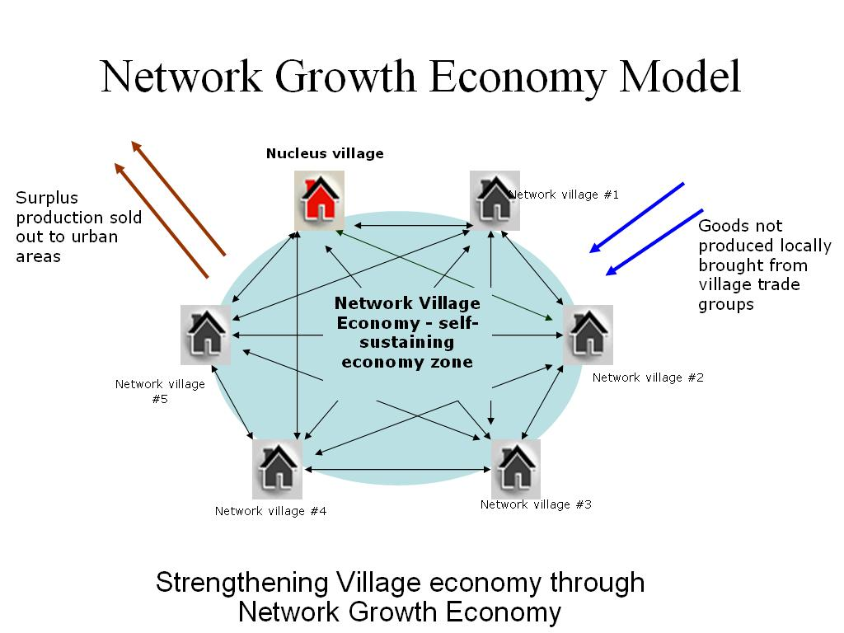
This project `Network Growth Economy through Local Self Governments (Panchayats) is a conscious effort of strengthening the panchayats (Local Governments) by creating network among the village level local governments by providing technical, financial and managerial trainings to the communities of these network villages to promote village industries and micro businesses. It is envisaged to create networks of 15 to 20 village panchayats by federating the local government leaders to work in a collaborative framework. This network of leadership will work with their communities to identify the skill level of their people, skills to be inculcated, raw materials available in their villages, space available to start the village level industries and organizing the women and men in Self Help Groups (SHGs) to work as entrepreneur individually or collectively. The training process will be facilitated by NGOs and governmental agencies. The communities will be organised (consisting of local government leaders, Self Help Group women and men, farmers representatives, youth representatives) to identify the village level activities and to formulate the marketing mechanism for their village products. There are number of items of daily use and house hold consumables which could be produced and marketed locally. The surplus of these productions could be sold to the nearest urban market. Likewise the goods required for the villagers but not produced in villages could be purchased in the urban markets and traded in the villages.
This process will solve the problem of migration of villagers to urban areas because number of direct and indirect job creation will take place in the villages. There will be challenges to build the skill level of the people to the standard required and also to convince the people to go for the local products. The panchayats have to play the pivotal role towards establishing the habitat solidarity among the villages of the clusters. Because of the Self Help Group movement, there is a great potential for success for this Network Growth Economy model hence the communities are going to play the major role in deciding, managing and controlling the process.
Panchayat Academy
By making Kuthambakkam a model panchayat, it would become a learning centre for other panchayats. In this way 25 – 30 panchayat presidents have been trained monthly in the panchayat academy. The training would be on the activities done in Kuthambakkam, the ongoing projects, Rights of panchayats, duties, 243G and 29 subjects given for panchayats, planning at the panchayat level, disaster management and mitigation training, rural industries, changes and happening in the local bodies of India and in other countries. Field exposure is also given.
Trust for Village Self Governance
TVSG was started to support the activities of the panchayat to generate funds and to get technical supports from outside. It also helps panchayat to implement schemes related to women, education and social development and to network panchayats to strengthen local self-governance.
During the implementation of housing for all programmes Rs 10000 was contributed by TVSG to the construction of each house. Training was given to the youths, SHGs with the support of TVSG. Small industries are run with this support.
Small and medium farmers were federated by TVSG and it they are helped them to get loans trainings were also arranged to them.
Source: http://www.modelvillageindia.org.in

Exercise:
Visit a model village and work out indicators of mortality and morbidity & vital events of life (birth rate. death rate, pregnancy rate, MMR, IMR, immunization card) by conducting surveys & by observing the record maintained by the adopted village.

SUPPORTIVE SUPERVISION

Supportive supervision is a process of helping staff to continuously improve their own work performance. It is carried out in a respectful and non-authoritarian way with a focus on using supervisory visits as an opportunity to improve the knowledge and skills of health staff. This type of supervision encourages open, two-way communication and builds team approaches that facilitate problem-solving. It focuses on monitoring performance towards goals and using data for decision-making. It
depends upon regular follow-up with staff to ensure that assigned tasks are being implemented correctly.

Controlling Supervision versus Supportive Supervision Traditionally, many supervisors used an authoritarian inspection or control approach to supervision. This approach is based on the thinking that health workers are unmotivated and need strong outside control to perform correctly. However, it has been shown that a supportive approach, where supervisors and health workers work together to problem-solve and improve performance, delivers improved results for the immunization program.
Table 8.1 compares the characteristics of the control approach and the supportive approach.
Controlling Supervision versus Supportive Supervision
Control approach | Supportive approach
- ƒ Focus on finding faults with  individuals.  - ƒ Supervisor is like a policeman.  - ƒ Episodic problem-solving.  - ƒ Little or no follow-up.  - ƒ Punitive actions intended.   | - ƒ Focus on improving performance  and building relationships.  - ƒ More like a teacher, coach, mentor.  - ƒ Use local data to monitor  performance and solve problems.  - ƒ Follow up regularly.  - ƒ Support provided.  

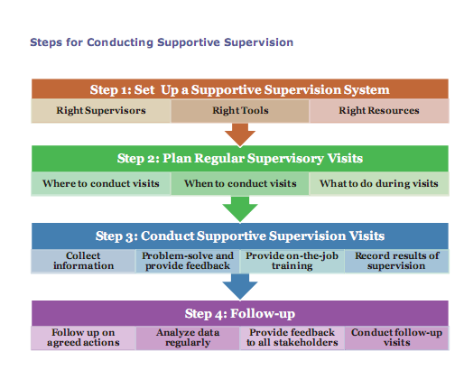

Step 1: Set Up a Supportive Supervision System

The three main "Rs" for an effective supportive supervision system are as follows.

Right Supervisors:

a core set of supervisors, well-trained on supportive supervision techniques and with updated information and skills on immunization issues. As the supervisors will be providing on-the-job training to health workers, it is important that the supervisors are themselves well informed and trained. As an initial step, provide refresher training for the core supervisors. The training could be on new policies or reporting procedures, changes to the immunization schedule etc or on supportive supervision techniques and participatory approaches.

Right Tools: availability of Supervisory checklists and forms (for recording observations, recommendations and follow up) and training materials and job aids (to update skills of health workers during supervision visits).

Right Resources: sufficient mobility, time allocated for supervision and follow-up.

Step 2: Plan Regular Supportive Supervision Visits

Regular supportive supervision visits are an integral part of the micro-plan and include

Where to conduct visits: Common criteria that can be used for selecting priority areas include:

- ƒ high number of unimmunized (in absolute numbers)
- ƒ high dropout rates
- ƒ low coverage rates
- ƒ poor reports from previous supervision visits
- ƒ areas with recent outbreaks of measles/AEFI cases; high risk areas for diphtheria, tetanus or measles
- ƒ new staff who may need training on immunization practices
- ƒ areas with little or no visits in the past
- ƒ problems identified by health staff or the community

When to conduct visits: Once you have prioritized areas to be visited over the next quarter/year, prepare a Plan for supervision (See Table 3.3 in Unit 3) with at least 4-8 visits planned per month. Consider the following issues:

- ƒ Plan visits on immunization session days.
- ƒ Supervise both fixed as well as outreach sessions.
- ƒ Inform the health worker about the scheduled supervision visit and never go without informing.
- ƒ Prepare the supervision plan taking into account the distance, transportation difficulties, or constraints due to weather and travel conditions.
- ƒ Schedule enough time to visit the site fully, and if possible provide on-site training; for example it may take two hours or more to meet the needs of a single supportive supervision visit.
- ƒ Carry checklists and practical tools/Job aids to provide onsite training.

Conduct the visit according to the plan, otherwise inform the health worker in advance. Analyze your planned visits versus held visits and record the reasons for not holding any visit as planned (e.g. lack of transport, competing priorities). The frequency of supervisory visits will vary and poorly-motivated staff, new health centers, new staff or new responsibilities will require more frequent supervision.

What to do during visits:
Although certain topics can be planned in advance, interventions may become evident during the visit or during discussions with health workers. Review data of the site, previous supervision reports, filled checklists and data for that PHC/ session site to identify the topics to cover during the visit.

Step 3: Conduct Supportive Supervision Visits

During a supervisory visit to a health facility or a session site, conduct the following main steps.
Collect information: Explain the purpose of your visit and use the supervision checklists (See Appendices 8.1 and 8.2) to:

- ƒ observe the health-facility environment and the health worker giving vaccination;
- ƒ review the adequacy of vaccines & logistics
- ƒ review the records
- ƒ talk with parents and community members;
- ƒ review recommendations from past visits;
- ƒ conduct a rapid community survey using the Rapid Immunization Coverage Assessment Tool
(See Appendix 8.3)

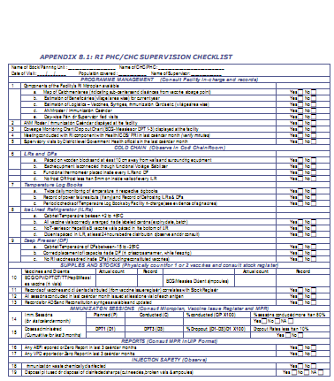

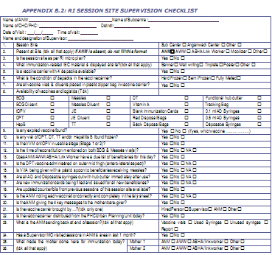

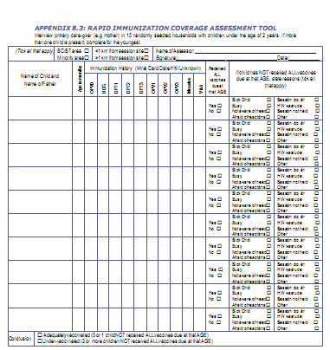

Problem-solve and provide feedback:

Describe the problem and its impact

- ƒ Focus on the problem and not individuals.
- ƒ Tackle one problem at a time.
- ƒ Explain the long-term and short-term impact of the problem.
- ƒ Be specific in explaining the problem. If possible, back it up with facts, rather than judgment alone.

Discuss the causes of the problem with health staff

- Identify the cause of the problem by asking “why” repeatedly and having open dialogue with the staff. Is it due to lack of skills or to an external factor?
- ƒ Do not blame others or blame the system.
- ƒ It may sometimes be necessary to seek explanation from other sources (e.g. community members, data, etc.).

Implement solutions and monitor regularly

- ƒ Develop, through common consensus, an implementation plan that details what, how, who and when.
- ƒ Implement those solutions that can be implemented immediately e.g. training on how to use hub cutter.
- ƒ Follow up on progress.

Provide feedback to the health staff concerned

- ƒ If you have some bad behaviour to comment on, begin with the positive, and be specific about weaknesses, rather than simply saying” that was not well done”.

- ƒ Give health workers reasons for their success or failure. Don’t just say “well done”. Give a reason saying, well done. You correctly read the VVM and took the appropriate action”. Don’t say “you are wrong” but rather “there may be problem. The data from your telly sheet do not match the data in the UIP reporting format. How can this can be corrected?”

Provide on-the-job training: by following the main steps when teaching a skill:

- Explain the skill or activity to be learned.
- Demonstrate the skill or activity using an equipment, model, or role-play.
- Allow health workers to practice the demonstrated skill or activity.
- Evaluate the health workers’ ability to perform the skill according to the correct procedure and give constructive feedback.

Record results of supervision
After each supervisory visit, prepare a supervisory report with a file copy. This report is vital for planning corrective measures as well as for use in future supervisory visits. The sample Supervisory Visit Report (Table 8.2) summarizes the key points from a supervisory visit and meeting.

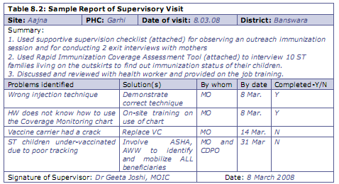

Step 4: Follow-up
Supportive supervision does not end with the conducted visit and you should plan for follow-up, which may include the following:

Follow up on agreed actions by supervisors and supervised staff

Analyze data regularly and establish regular communication with supervised staff to see if recommendations are being implemented.

Provide feedback to all stakeholders discussing equipment supply and delivery problems with higher levels
Conduct follow-up visit
- ƒ Review reports from previous supervision visits and continue to work on the issues raised. Tell health workers what you have learned from the previous visit, in order to avoid repeating the same information
- ƒ Observe health workers to see if bad behaviours or attitudes have been corrected and, if it is the case, congratulate them. Check if any perceived lack of improvement is due to hidden problems that need to be addressed.
- ƒ Fulfill promises made at the previous visit (i.e. if supplies or other support had been promised).

Conducting Effective Review Meetings
In order to conduct effective review meetings with health workers and staff from other line departments, NGOs and community members, you should:

- ƒ Set clear objectives for the meeting.
- ƒ Prepare and circulate an agenda with the list of the topics to be covered; resources required and the time duration.Do not deviate from the agenda and ensure that set objectives are met. (See Table 8.3)
- ƒ Assign, to concerned supervisors and colleagues, talks on specific technical topics.
- ƒ Assign responsibilities of logistics support to a designated staff member.
- ƒ Identify the meeting participants and the chairperson.
- ƒ Inform the participants in advance of the venue and date. To avoid cancellation of the meeting due to competing priorities, share in advance the dates of meeting at Block / District level and with other nodal officers. Otherwise, delegate the responsibility of chairing the meeting to another colleague.
- ƒ Ensure that the meeting is focused and participatory and not just collection of monthly reports. Keep listening and summarizing the key points raised after intervals.
- ƒ Ensure that minutes are taken with actionable points and time-lines.
- ƒ Forward unresolved issues to block/district level for necessary actions.
- ƒ Share the tentative dates of the next meeting.

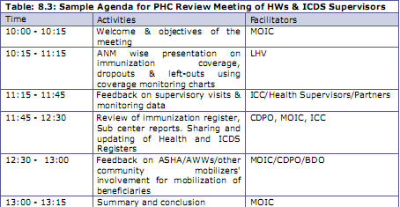
Activity 3
Supportive Supervision
Learning Objectives
At the end of the session, participants will be able to:
- Compare between approaches to supervision
- List key steps for effective supportive supervision
- Conduct an effective meeting
A. Approaches to Supervision
1. Read aloud the posted Learning Objectives (Poster 17).
2. Ask participants what they understand by Supportive Supervision and how it is
different from the traditional control approach to supervision. List their responses on a flipchart. Prompt for responses covered in Table 8.1 in the Handbook, if missed.

B. Steps for Conducting Supportive Supervision and Effective Meetings
1. Divide participants into 4 groups and ask them to read Ask them to list the key points on the flipchart and select a representative to present to the plenary. Each group would get 15 minutes to read and prepare the flipchart and 5 minutes each to present to the plenary.
Group 1: Step 1 (Set up a Supportive Supervision System)
Group 2: Step 2 (Plan Regular Supervisory Visits)
Group 3: Step 3 (Conduct Supportive Supervision Visits)
Group 4: Step 4 (Follow Up) and Conducting Effective Meetings

2. Assign the participants to the same groups as in the previous step, distribute the Supervision Checklist (Handout 8) to each participant and give them the task of reading it in detail within 20 minutes. Ask participants within the group, one by one, to read aloud each point in the checklist. Discuss each point in some detail and ensure that participants have a similar understanding of each point.

3. Assign groups the task of preparing a role play based on the Supervision Checklist (Handout 8) within 10 minutes. Each role play would last 10 minutes.
Group 1: Example of Ineffective Supervision in a PHC/CHC
Group 2: Example of Effective Supervision in a PHC/CHC
Group 3: Example of Ineffective Supervision in a Session Site
Group 4: Example of Effective Supervision in a Session Site
4. Suggest that participants could enact the roles of a Health Worker providing immunization services, a Medical Officer conducting a supervisory visit to the session, the mother of an infant beneficiary and an ASHA/AWW. The other scenario could be that of a Medical Officer supervising the Cold Chain Handlers, LHVs etc.
Arrange the necessary props like vaccine carrier, tally sheet, Immunization cards, Immunization register, Vaccines, AD Syringes etc. beforehand. The ANM and mothers should create a scenario where they do several things wrong. The job of the supervisor will be to find all the mistakes. The difference between the effective and ineffective supervisors is in how the feedback is provided.

5. At the end of each role play, thank the groups and invite participants to summarize what they have observed and learnt from the role plays.
Did the supervisor find everything that was done wrong? What was correct or incorrect with the style of supervision?
Ask the persons playing the role of the ANM in both styles of supervision to describe how they felt when being supervised during the role play.

Source:
Immunization Handbook for Medical Officers
Routine Immunization Immunization Handbook for Medical Officers Facilitators Guide

HOSPITAL MANAGEMENT INFORMATION SYSTEM

Definition-
A two directional information flow, with systematically designed arrangements and organisation to generate, collect, analyse, store, present and make available required information to different managerial levels for improved and timely decisions and actions.
This is important mainly for

- Management system
- Human resource system
- Logistic system
- Management Information System.

MIS consist of three characteristics

Records Data Information

A record describes any transaction that takes place between a client and service provider. For example, a child getting BCG dose is a transaction; a woman registering for ante-natal service is another transaction; sterilization operation is also a transaction. Many such actions take place daily in any health programme. Each of these transactions contain such information as ‘who’ did ‘what’ to ‘whom’, ‘when’ and ‘where’ (the 5-Ws).

When many such records are compiled, they constitute ‘data’. That data when analysed, produces ‘information’. For example, each time when an ANM gives immunization to a child and records child’s name, age, sex, type of dose given, date when the dose was given and the place she creates a ‘record’. Each month when she compiles those records and reports the number of children immunized by age, sex, type of dose, she creates ‘data’. By analysing that data information is generated such as, did immunization coverage reached the target level? Was any area not covered? Was the immunization coverage among girls as good as that among boys?

The amount of information one can obtain form data is directly proportional to the care with which each transaction is recorded. With the availability of computers at the districts level, our ability of analysed data has substantially increased. But the limiting factor has been the quality of transaction recording. Manual recording of data is often incomplete. Some hospitals use network computers to capture each event in the patient care such as patient’s diagnosis, lab test results, treatment, outcome, costs etc. The resulting information is much richer specially because data are captured during service delivery process. The health workers keep rough notes on the services they provide. Later they are expected to enter that information in the registers but this task is often neglected.

Information systems can be of two types: (1) based on reports compiled by workers; (2) based on transactions data as recorded in registers or case-sheets. The other differenced between the report based system and the transaction based systems are as follows

Box : Characteristics of Report – Based and Transaction-Based MIS
Dimension | Report-Based MIS | Transaction-Based MIS
Data Source | Periodic reports / client surveys | Case paper / service record
Reporting Frequency | Periodic | Real time
Information unit | Village / Health Centre | Client
Information Content | Decided by System Designer | Decided by manager, can be flexible

Currently in India, most HMIS follow a report-based design. A few transaction-based systems have been developed, mostly by NGOs and under special projects. A model combining the report and transaction-based approaches was also tried in one of the projects, with some success. In this model only a sample of client records were computerized while routine reports contained a few simple indicators which could be easily compiled. This combination was found to give advantage of both the systems. Worker’s compilation work was reduced; tedius tabulations like age-parity distribution of FP acceptors by method were done on computer on a sample basis, cases. With increasing availability of computers and computer literacy among people, HMIS is likely to become more client based, over time.
After deciding on the type of information system to be developed, the next step is to decide how to measure programme performance. This is a very important step which decides what information the managers need and must get. One complaint always heard about the current HMIS is that managers do not get adequate information. This does not mean they get less information because HMISs are overloaded with information. Studies have shown that health workers spend 30-40 per cent of their time on collecting and reporting data. Yet, the managers complain because some critical information is not available. For example, the family planning programme gathers a lot of data; but it does not collect data on contraceptive continuation rates or incidence of side-effects.

A useful thumb rule is to restrict the number of indicators to 10-12. These way system designers are forced to come up with very important indicators and not burden the system with too many unnecessary ones. Another practical rule is to restrict number of indicators such that they can be presented in one normal sized page. That way managers can get a comprehensive view of their performance at a glance. Following are some of the guidelines one can use to select critical indicators:
- Select two-three indicators each from Input, Output, Outcome and Impact. This will limit the total number of indicators to 10-12, but the managers will be able to monitor the entire management process – from input to impact. Focussing on say output indicators and excluding input or impact indicators can result in managers getting distorted view of the programme.

- Select indicators for activities which are new or difficult to implement. The Monitoring System developed under the Target Free Approach has selected 27 indicators. These include indicators on new programme activities such as treatment of RTI and STDs, and on neglected activities like contraceptive follow-up and post-natal care.

3- Select indicators to monitor aspects about which people complain the most. Some systems monitor delayed payment of travel allowances to health workers, or non availability of medicines at PHCs because about these one hears many complaints. Unfortunately, not all areas about which people complain, are easy to monitor. For example, people complain about the rude behaviour of health staff or about having to the ‘speed money’ to get any service at government hospitals, but these are difficult to monitor through information system

Health information can be collected from several sources. These are:

- Worker’s diaries
- Family registers
- Clinic registers
- Periodic reports by health workers
- Supervisor’s observations
- Rapid surveys
- Exit interviews of clients
- National sample survey,
- Special studies.

The first and foremost use of information, as the health staff perceive, is to send reports to the Centre. At the State level, information is used to monitor achievements of targets. Sometimes, information is used to introduce an element of competition among District and to put pressure on low-performing Districts to act.

Structure of MIS at PHC level

Checking and Control Procedure
Progress Report (To DHO)
Policy guidelines and target (from DHO)
Data Compilation and Computation Logic
Information Bulletin (for display)
Feedback/Instructions (to MPW)
Field activities (from MPW)
Programme Related Information
Activity Related Information
Store/Supply Related Information
PHC (Computer)
Subcentre (MPW M & F)
Centre
(NIC Health Authority)
General Information (from other public departments)
Employee Related Information
Store/Supply Related Information
Activity Related Information
Programme Related Information
Field activities (from MPW)
Feedback/Instructions (to MPW)
Information Bulletin (for display)
Data Compilation and Computation Logic
Policy guidelines and target (from DHO)
Employee Related Information
General information (from other public departments)

Information Flow in MIS under RCH Programme
Centre
(NIC Health Authority)
Subcentre (MPW M & F)
PHC (Computer)
District (Statistics Cell)
NIC District Computer
NICNET
District Health Authority
District/Special Hospital Campus Information
Programme Manager
State Health Directorate
- Programme Manager
- Family Welfare Deptt.
NICNET
State
(NIC Health Authority)
PHC (Clinic, Lab & Stores)
Data Flow
Feedback

For example, district needs to know which vehicles are off road and for what reasons. Accordingly it can take the corrective actions of repairing vehicles, reallocating petrol budget or assigning drivers if those are the problems. State needs to know the pattern and rate of vehicle breakdown in the State. If the rate is very high, State could take managerial decisions such as establishing mobile repair unit, or buying new vehicles, or increasing petrol budget. At the GOI level, the policy questions that may need answers are: Should PHCs have vehicles? Should those be bought or rented?

Exercise of HMIS
Steps in HMIS

Information required: For effective management, the information required must be identified and specified.

Collection of data from institutions and field level: The data from the institutions and field is to be collected with predetermined periodicity in a systematic manner.

Conversion of data into information: The data needs processing to convert it into information like rates, ratios, proportions, graphs etc. This process of conversion of data may be carried out at different levels from most peripheral to central. At each level the format of collection of data and methods of processing are to be specified.

Example: Malaria report of health unit, Paithan, Maharashtra, September 2004.

No. of Slides Examined
Blood Examination Rate= ------------------------------- X 100
No. of New Cases

= 364
------- X 100
3998
= 9.10

Time about transmission of data / information: The frequency and time frame at each level of organization, these reports are to be sent is to be specified. This should be followed scrupulously. Non-compliance at any level will disrupt the system.

Interpretation comparison and evaluation: The MIS mainly functions for this particular activity. The timely interpretation, comparison and evaluation of data along with corrective action to be taken are very vital.

Exercise
- Students to go to subcentre and observe all the existing register eg. R1 , R2 , ….. They should make a note of each register like immunization , eligible couple ,pregnant mother , water sample , malaria , JSY , iron folic acid , adolescent girl information , fundings , population , contraception ,reference , ANC.
- Students to go to subcentre of allotted place to check register of ANM for immunization and convert this data to% of children covered under UIP.
- Find out the % of eligible women receiving two dose of TT injection during anti natal period (Take data from population register , eligible couple register , pregnant mother register and ANC register .
- Make report for MIS in department of PSM of your college.
- Enumerate the virus indicators on which the report is submitted every moth by PHC medical officer.

SITUATIONAL ANALYSIS OF HEATH SYSTEM
Situational analysis:
This section will in detail inform the situation in the chosen areas includingexisting situation, perceptions and practices that contribute to the situation;and detail what services are available from the government system or privateproviders, gaps. Towards this it is essential to understand the available datafrom the various sources.

Each source has a specific purpose and contributes to strengthening yourproposal. Do use all the sources. Information from these sources would help youto establish the authenticity of your information and help you make interventionsmore focused.

a) Sources of primary data: Baseline survey, FGD, key health informantinterviews-MO-PHC, ANM, AWW, TBA, discussion with block health officials.

For example, if you were collecting information FP and unmet needs, thebaseline survey would provide data on number of eligible couple per 1000population; CPR, method specific rates, type contraceptives used, age atmarriage etc.

This will be complemented through FGD, which will bring out the perceptionsand existing health practices in the community. For examples, son preference,religious believes or sanctions, fear of health implications if men get sterilized,social strictures leading to early marriage of girls, non-availability of counselling,attitude of the service providers etc.

The key health informant interviews with ANM could complement this furtherby giving an insight about services that are well accepted in the communityand also an insight into those that resisted and reasons for such resistance, orinformation on the quality and reliability of the supply system contributing to thestatus related to unmet needs.

Interview with elderly women or TBAs could give perspectives on deliverypractices.

Key health informant interview with the MO-PHC could give you information onwhat support services and products the local health system can provide in yourproject area-for example,

- From where the supplies can be procured and
- What records need to be kept and reported
- Where to refer in the event of serious side effect
- What kinds of health camps are held and how FNGO can participate or conduct the same?

b) Sources of secondary data: records of panchayat, ANM and AWW registers/records/reports (This will back up your information from the primary sources)For example, ANM and AWW records will provide – eligible couple numbers,current contraceptive prevalence rate, methods used, and parity thus helping to
Revalidate the data generated from the base line.

Rationale for selection of interventions: All the above (demographic data,health information, community profile and situation analysis etc) along with theexpertise and past experience of the FNGO will inform the rationale for FNGOinvolvement in the chosen area for RCH service delivery

(E.G: Strong organizational capacity with permanent staff, communitypresence and credibility or past experience in addressing women’s health issuesparticularly related to pregnancy and childbirth and good rapport with the localhealth/Panchayat system).

Example , you want to involne the community regarding improvement of immunization serrvices in an area.
Conduct a situation analysis
- Identify well performing and poor performing areas interms of data on vaccination session attendance andlocal coverage levels
- Assess through meetings, small group discussions ordiscussions with opinion leaders (See Appendix 7.1)
  - community awareness and perceptions aboutimmunization services
  - perceived barriers to immunization (related toquality of immunization services and thedge, attitudes and practices)
  - issues affecting physical access to services (location,frequency, schedule)
  - Access by special groups (minorities, migrants etc.)
- Explore the problems and possible reasons for left-outsand dropouts. Jointly seek possible solutions.
- Assess the current extent of communityinvolvementwith immunization services and discuss possiblecommunity support.

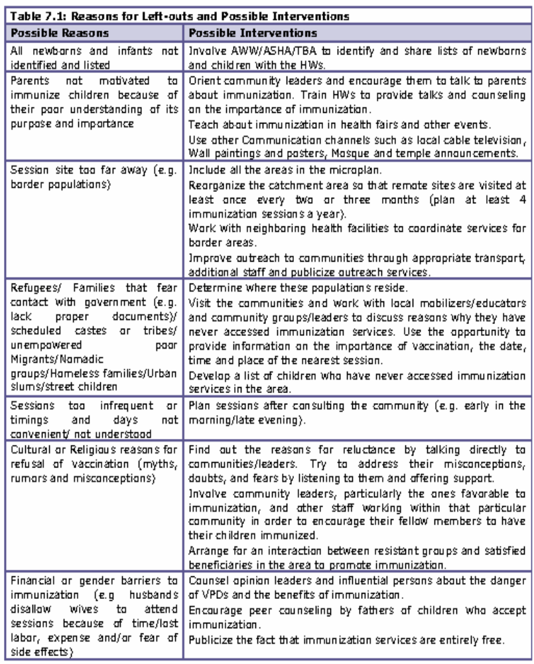

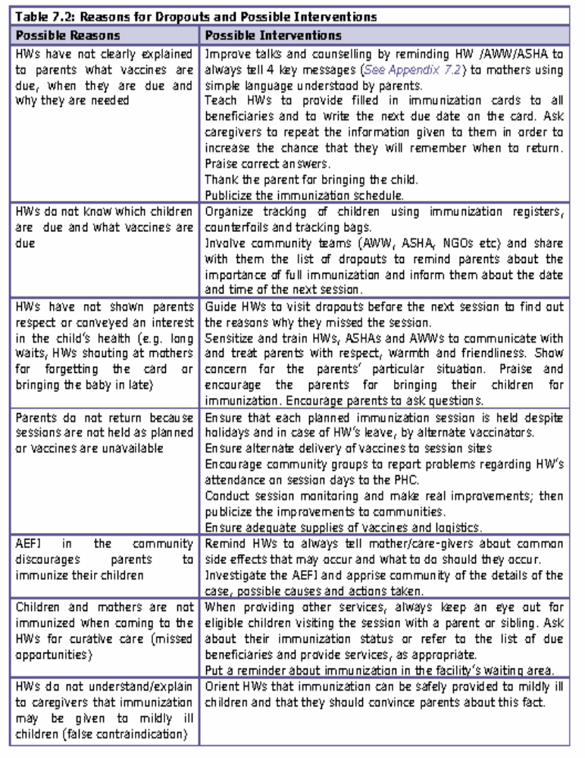

REFERRAL SERVICES
Referral service is a system by which patients, while undergoing treatment by a doctor of the patients choice. Or at a place of the patients convenience. Are given facilities in the hospital to avail of the specialized consultation. Medical care and ancillary services whenever required.
THE CONDITIONS SHOULD BE SATISFIED FOR EFFICIENT REFERRAL SYSTEM TO FUNCTION ARE :
  - Recognition of a referral system by the govt.
  - Orientation to the referral system amongst
  - Provision in the OPD and ancillary service deptts for referred cases to be seen and attended to
  - Organisation for medical record section to service the referred cases.
  - Provide good transport facilities.

Box 1. Components of a referral system
- Health System
  - Service providers (public and private sector) and quality of care
    - Strengthened primary health care services
    - Clarity of level and role of each facility
    - Availability of protocols of care for conditions for each level of facility
    - Availability of communication and transport
  - Performance expectations
    - Expectation to refer appropriately and follow protocols of care
    - Expectations that health workers and clients adhere to the referral discipline
    - Regular supervision and capacity building
  - Involvement of organizations
    - Ministry of Health
    - Medical and nursing schools
    - Medical and nursing professional associations
- Initiating facility
  - The client and their condition
  - Protocol of care for that condition at that level of service
  - Treat and stabilize client – document treatment provided
  - Decision to refer
- Referral practicalities
  - Outward referral form
  - Communication with receiving facility (make arrangements as appropriate)
  - Information to the client and their family/support network
    - Reasons and importance of referral, risks of non-referral
    - How to get to the receiving facility – location and transport
    - Who to see and what is likely to happen
    - Follow-up on return
  - Empathy - understanding of implications for client and family/support network
    - Overall fear
    - Cost of transport, treatment and family accommodation
  - Referral register to monitor follow-up and gather statistics
- Receiving Facility
  - Anticipate arrival and receive client and referral form
  - Provide care – document treatment provided
  - Plan rehabilitation or follow-up with client and family/support network
  - Back referral form
  - Feedback to initiating facility on appropriateness of referral
  - Referral register to monitor follow-up and gather statistics
- Supervision and capacity building
  - Monitor outward and back referrals
    - Number and appropriateness of referrals – compliance with protocols
    - Quality of documentation
    - Consistency of follow-up
  - Provide feedback, support and training for health staff
  - Provide feedback to central level

REQUISITES OF AN EFFECTIVE REFERRAL SYSTEM
  - Unified Administrative control
  - Unified system of records
  - Identification of the patients
  - Transport facilities
  - Entry points
  - Team building
  - Movement of specialists
  - Pay clinics
  - Private Practitioners
  - Involve the voluntary sectors
  - Service supports.
THE PROBLEMS FACED WITHIN THE SYSTEM ARE :
  - Lack of trust between hospital and community oriented health services personnel because of lack of contact among themselves and organizational linkages. If these are frequent and const. Staff will know and have confidence in each other.
  - Lack of well designed referral system with defined procedure, management support and appropriate reporting forms.
  - Lack information at the various levels of primary health care systems regarding available facilities and capabilities. Of the system.
  - Lack of Logistic support.
  - Inadequate training or guidance at each level on referral criteria and in what conditions should be referred to the higher level.
  - Off loading of the patients by community services to the hospital because of lack of adequate training and clinical experience.
  - The general importance of making the referral services obligatory is still not realized.
  - This in not yet viewed as integral part of total health system.
THE DRAW-BACKS OF THE REFERRAL SERVICE SYSTEM ARE :
  - The patients do not have confidence in the local or primary health centres. Hence by pass them and directly reach hospital or do not report back for follow up care.
  - Referred patients do not arrive or arrive after undesirable delay due to problems of distance transport or finance.
  - Hospitals/Specialised health institutions consider themselves as independent entity, rather than a integral part of the total health care system.
  - The Hospitals are more overwhelmed with patients through
          - Poorly judged referrals
          - Emergency
          - Inappropriate self referral.
  - Inadequate flow of information on either side.
  - Referred patients are not well received and/or specially attended
  - Inadequately trained and unmotivated health staff.
  - Poor publicity and awareness among general public
  - No fixed cliental

Figure 1. Referral system flows
Initiating Facility
The client and their condition
Protocol of care
Provide care and document
Decision to refer
Referral practicalities
Outward referral form
Communicate with receiving facility
Information to the client
Empathy
Referral register
Receiving Facility
Receive client with referral form
Treat client and document
Plan rehabilitation
Referral practicalities
Back referral form
Feedback to initiating facility
Referral register
Supervising Organization
Monitor referrals
Ensure back referral
Feedback and training for facility staff
Feedback to central level
Overall Health System
Network of service providers
Adherence to referral protocols
Transport, communication and other resources

Overall Health System

Referral System Tools
There are two sample tools on the following pages:
- Sample tool 1: Referral form
  - Prepare one copy to send with the client, and keep one copy in the client notes.
- Sample tool 2: Referral register
  - The register has a page for referrals made OUT from a facility and referrals received IN to a facility.
  - Information on back referral of clients referred out from the facility should be made on the same line as information regarding the original referral out. This facilitates follow-up.
  - Please also note, that the two referral registers have a column to indicate whether there is any problem regarding the appropriateness of the referral. Keeping track of this information will help identify if there are problems with referrals from a particular facility, or problems with referral of clients with particular conditions. Knowing this can help focus in-service and continuing education of health workers.

Tools to Facilitate the Referral Process

In this document, different forms and tools are discussed, such as a directory of services, referral forms and referral registers. Having such tools standardized and available to organizations in the referral network is critical to maintaining accuracy, efficiency and consistency.

These sample tools can be adapted for different settings. Each tool is accompanied by instructions that describe how the tool is designed to be used. The tools presented include:
- Directory of services (and data collection and update form).
- Referral form.
- Client tracking form.
- Referral register.

Diagram 1: The referral process and corresponding forms

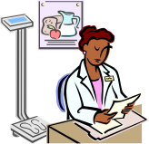
Make referral
Receive client
Follow up
Referring Organization
(health facility or CBO)
Receiving Organization
Referral form:
Review form returned by receiving org or client
Referral form:
Client takes to provider
Referral form:
Fill out part B
Return to referring agency or client
Referral register:
Complete
Update
Client tracking form:
Fill out
Place in client file
Referral register:
Complete
Update
Directory:
Consult,
Find provider
Referral form:
Fill out part A
Give to client
Client tracking form:
Update
Referral register:
Complete
Update

Name of facility: Referral Form original / copy
Referred by: | Name: Position:
Initiating Facility Name and Address: |  |  |  |  | Date of referral:
Telephone arrangements made: | YES | NO | Facility Tel No. |  | Fax No.
Referred to Facility Name and Address:
Client Name
Identity Number |  |  |  |  | Age: |  | Sex: | M | F
Client address
Clinical history
Findings
Treatment given
Reason for referral
Documents accompanying referral
Print name, sign & date | Name: |  |  | Signature: |  | Date:
Note to receiving facility: On completion of client management please fill in and detach the referral back slip below and send with patient or send by fax or mail.
--------------------------------------------------receiving facility - tear off when making back referral------------------------------------
Back referral from Facility Name |  |  | Tel No. |  | Fax No.
Reply from  (person completing form) | Name: |  |  |  | Date:
Reply from  (person completing form) | Position: |  | Specialty:
To Initiating Facility:
(enter name and address)
Client Name
Identity Number |  |  |  | Age: |  | Sex: | M | F
Client address
This client was seen by:  (give name and specialty) |  |  |  |  | on date:
Patient history
Special investigations and findings
Diagnosis
Treatment / operation
Medication prescribed
Please continue with: (meds, Rx, follow-up, care)
Refer back to: |  |  |  |  | on date:
Print name, sign & date | Name: | Signature: |  |  | Date:

Referral Register

Date | Client Name | Registration /ART Number |  | Client on ART? (yes/no) | Referred by: (organization name) |  | Services referred for: (use codes below) | Referred to:  (organization name) |  | Services provided:  (use codes below) | Services completed (yes/no) |  | Follow-up needed: (yes/no)
For services use the following codes:
- Adherence counseling  - Antiretroviral therapy  - Child care  - Clinical care  - Education/ schooling  - Family planning  - Financial support |  |  | - Food support  - HIV counseling and testing  - Home-based care  - Legal support  - Material support  - Mental health services |  |  | - Microfinance  - Nutrition counseling  - OB/GYN services  - Peer counseling  - PEP services  - Pharmacy  - PLHA support |  |  | - PMTCT services  - Post-test clubs  - Prevention services  - Psychosocial support  - Social services  - Spiritual support  - STI services |  |  | - Substance abuse management  - Support for domestic violence victims  - Treatment support  - TB services  - Youth support groups  - Other________

Register of Referrals OUT

Date referral made | Client Name (M or F) | Identity No. | Referred to  (name of facility / specialty) | Referred for | Date Back referral received | Follow-up required  YES / NO | Follow-up completed  YES / NO | Appropriate referral  YES / NO

Register of Referrals IN

Date referral received | Client Name (M or F) | Identity No. | Referred from  (name of facility / specialty) | Referred for | Appropriate referral  YES / NO | Summary of treatment provided | Date Back referral sent

DATA TRIANGULATION
In the social sciences, triangulation is often used to indicate that more than two methods are used in a study with a view to double (or triple) checking results. This is also called "cross examination".[1]
Triangulation is broadly defined as synthesis and integration of data from multiple sources through collection, examination, comparison, and interpretation. It is used to answer different question, ranging from explaining the trends and the levels of the HIV epidemic to assessing the population impact of HIV prevention and treatment programmes. It is done mainly by using quantitative analysis and interpretation of data coming both from HIV and other surveillance (e.g., sexually transmitted infection) and programme-based sources and vital statistics registries. Triangulation can be effective when there are multiple data sources that can be analyzed to inform policy or programme decision-making.
The interpretation of data coming from the single surveillance or programme-based source is influenced by various factors, including sampling methods and data collection instruments and depend heavily on their quality, completeness and precision. Interpretation of the dynamics and the further spread of HIV, and the influence that the prevention and treatment programme have on these epidemics requires development and validation of analytical tools that use different data sources and enable higher external validity of findings. Additionally, by examining information collected by different methods, by different persons, and in different populations, findings can corroborate each other and reduce the impact of both systematic bias and random error present in a single study. In contrast to meta-analysis, triangulation synthesizes information from multiple sources collected by diverse methodologies, including quantitative and qualitative designs as well as programmatic and research data. Whereas single research studies seek to maximize scientific rigor through internal validity, triangulation seeks to make the best public health decisions based on the available information.

Examples
Examples of triangulation research questions using different HIV data sources are:
- Tracking the epidemic:
  - Is the HIV epidemic among men who have sex with men going up, down, or staying at the same level in the era of antiretroviral therapy?
- Measuring the effect of interventions:
  - What is the impact of ART and PMTCT programmes on adult and infant mortality?
- Coverage with interventions:
  - What is the current coverage with prevention and treatment interventions among injection drug users in the city/ province and what are the gaps?
  - What is the reach and intensity of HIV prevention programmes in city/ province from 2000 to 2007?
- Problem identification:
  - What is the level of HIV and STI epidemic in sex workers in city/ region? What impact can STI interventions have on progression of HIV epidemic?
  - What contribution in-country migrations make to HIV epidemic?
  - What groups contribute most to new HIV infections in your country or province?

